**Hardware, Software, Input and Output Devices**

Using the above words list all the **output** devices in this box:

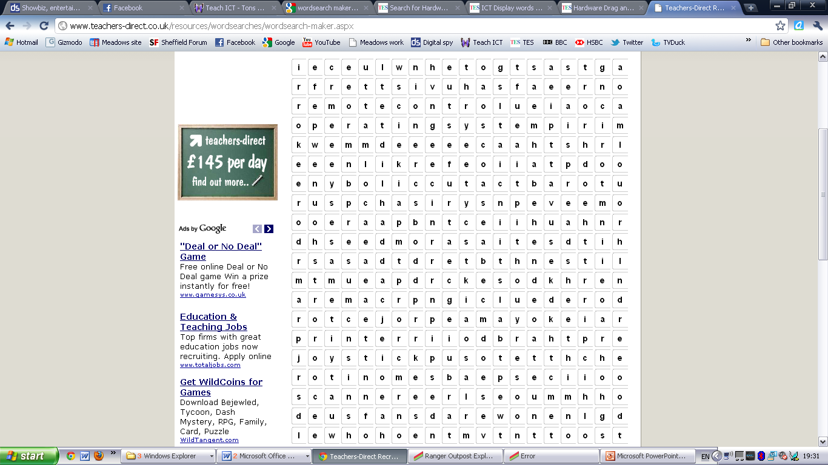

**Keywords to find**

Keyboard

Speaker

Mouse

USBstick

GraphicsCard

Printer

Monitor

Keypad

Touchpad

Remotecontrol

Scanner

Camera

Webcam

Projector

Microphone

Operatingsystem

Processor

Using the above words list all the **input** devices in this box:

Name:

What is inside my computer?

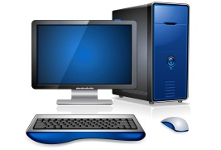

My Objective

*I can explain what hardware is inside a computer*

Task 1: True or False  
Watch the video in lesson and decide if the following statements are true or false? Circle the correct answer.

1. CPU stands for Computer Professional Unit. **True/False**
2. The CPU is often referred to as the “Brain” of the computer. **True/False**
3. RAM is where you store your work files e.g. a presentation. **True/False**
4. Hard drives are slower but cheaper than solid state drives. **True/False**
5. Expansion slots can be used to upgrade a computer. **True/False**

**Mark**

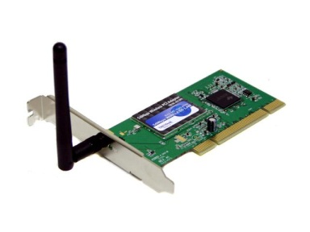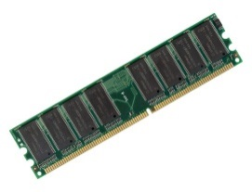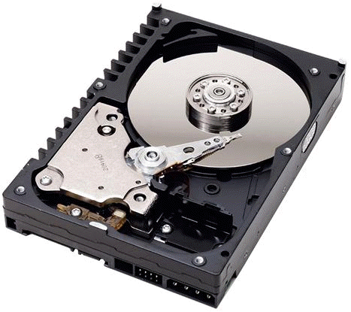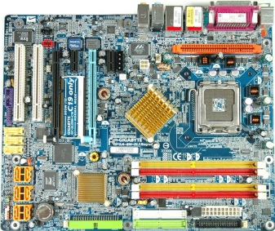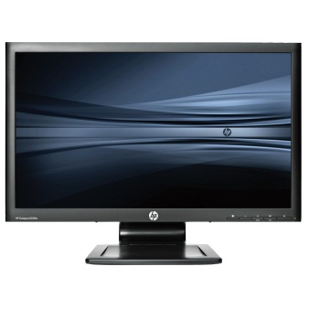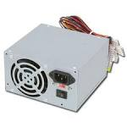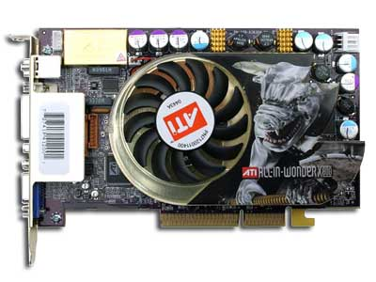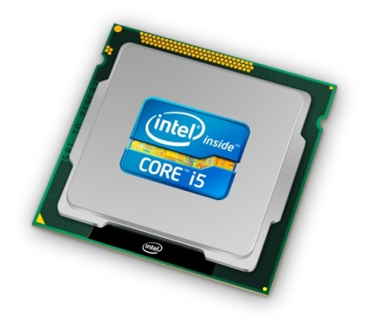

Task 2: Name that hardware  
Use the internet to identify what the different pieces of hardware are below.

**Hardware**RAM Graphics Card  
CPU   
Power Supplier Monitor  
Hard Drive   
Wireless Network Card  
Motherboard

**/5**